**Website Planning Document**

**Site Purpose:** Invite all users, and people in general, to eat healthy food giving them the opportunity to learn where they can purchase that food from the website and make the company deliver it.

Customers could also understand that by buying from Bountiful Foods Company they will be sustaining local farmers.

Also, the site will offer the unique possibility to create custom fruit drinks and see all the nutrition factors while making the order.

**Target Audience:** the website speaks to people that eat fruit regularly, care about the origin of what they eat, like to sustain local commerce, and like to eat healthily.

70% of the Audience are women starting from 20 years old, not necessarily wealthy, but willing to spend some money to have better products.

Part of them are mothers and wives that want their families to stay healthy.

They also like juice and love the possibility to make their own fruit juice taste.

**Prototype:**

**Color scheme and Typography:**

**Header and Footer:**

|  |  |
| --- | --- |
|  | Background-color: #487890  Font: Arsenal |

**Menu:**

|  |  |
| --- | --- |
|  | Font-color:  Background-color: #64Fcc9  Hover-color: #FFE135  Font: Arsenal, all-caps  #487890 |

**Buttons:**

|  |  |
| --- | --- |
|  | Font-color: #487890  Background-color: #64Fcc9  Hover-color: #FFE135  Font: Arsenal, |

**Paragraph:**

|  |  |
| --- | --- |
|  | Font-color: #20183a  Font: Raleway  Title (font-color): #FFE135  Font: Arsenal |

**Wireframe Sketches:**

**Desktop:**

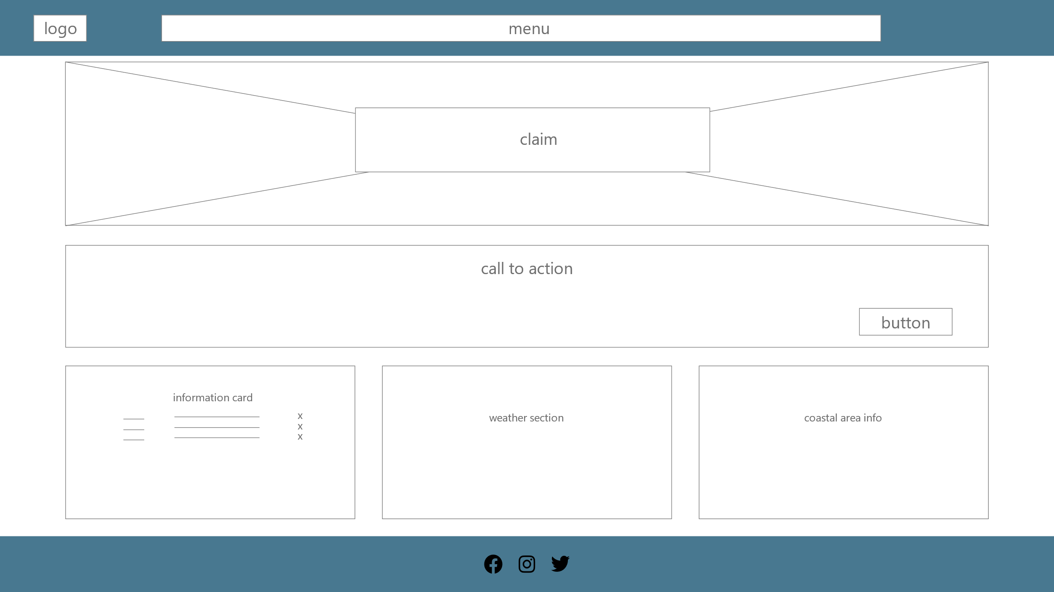

|  |  |
| --- | --- |
| **Tablet** | Phone |
|  |  |